Delivering quality

Background and evolution of quality
- Quality underpins operations, importance of how we define it both as a product and service, how we deliver this definition, how we can diagnose quality problems.
- 30 years ago, there was a notion of an “acceptable level of quality”; quality wasn’t always embedded in expectations and operations.
  - However, in the early 1980’s, Japanese firms blew away Western competitors based on quality, with Sandcone model effects taking hold.
- Quality is the order winner in some industries e.g., Honey thermostats, but in most industries, it is now an order qualifier, a bare minimum.
- Quality failures can create spectacular news stories which lead to very bad publicity for companies e.g., United Airlines scandal
  - Medical errors third because cause of death in the USA. Defects more of an issue than lead times.

Nature of defects
- Assembly line defects are more problematic than ‘Swiss cheese’ situations. In an assembly line with a 2% defect chance at each of 4 stages, the chance of success (0.98)^4 = 92.2%
  - Swiss cheese model of defects exists where there are checks in place at each stage of the process, meaning that all stages must be defective to lead to a fatal or flawed outcome. Here, the chance of success would be 1-(0.02)^4 = 0.99999984%
- To improve the process, you need to capture near misses, which come from internal process variation, as well as actual bad outcomes.

Quality at the source
- A basic tenet of operations management is to identify and rectify quality failures as soon as they occur. This is quality at source, and avoids passing on defects to the next stage.
- Costs of defects increase at each stage of the production process, and the information on the defect has time value. For example, at the final stage there are additional costs such as warrantees, loss of reputation, loss of market share.
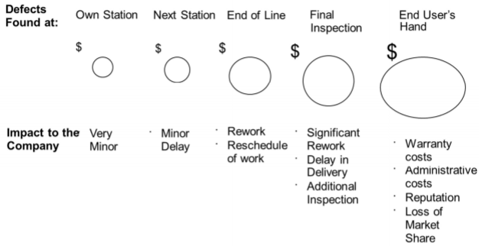

Defining quality

Alternative definitions
- Product-based: precise set of characteristics that the product must have
- Value-based: quality vs cost/price
  - Subjective quality – depends on contexts aside from price, such as cultural biases
- Conformance-based: free from defects
- User-based: fitness for purpose
- Ease of feedback and obtaining returns
- Gap-based: expectations minus performance

Dimensions of product quality (Garvin, 1987)
- Performance: primary characteristics
- Features: unique features
- Conformance to specifications
- Reliability: consistency, will it be available when needed?
- Durability: product lifespan
- Serviceability: policies for malfunctions
- Aesthetics: effect the product has on the customer’s senses
- Perceived quality: subjective quality based on the above criteria

Dimensions of service quality (Berry, 1990)
- Reliability: ability to perform promised service on time and dependably. Main variable
- Tangibles: quality of physical facilities, appearance of personnel etc.
  - Banks used to signal wealth and security through large marble buildings.
- Responsiveness: willingness to help customers and provide prompt service
- Assurance: courtesy of employees, and ability to convey trust and confidence
- Empathy: provision of individualised attention to customers

Technical/functional service quality
- Few operations create a pure product or pure service.
- Technical service quality is the “what” of the service and the functional service quality is the “how” of the service.
  - Customers may be unable to evaluate the technical quality of the service, but they can evaluate the functional quality
  - Functional measures are the 5 covered above.

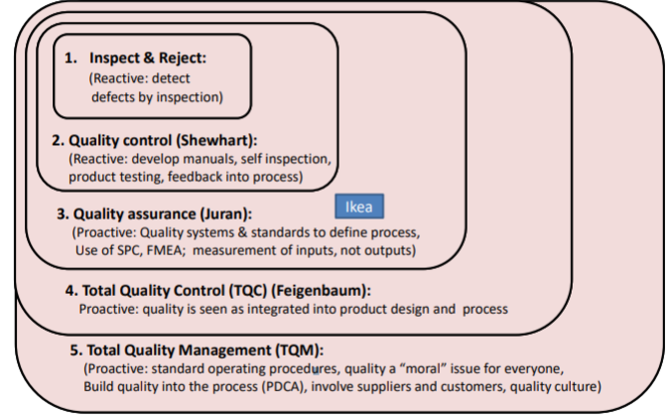
Managing quality as a system

From inspection to prevention
- Inspect and reject: industrial revolution separated the role of labour from delivery of quality via mass production, as opposed to small workshops who signed quality off.
  - Bias was now that workers worry about production, management worry about quality (through inspection).
  - Slack and Brandon-Jones: prevent out of specification products reaching the market
- Quality control developed by Shewhart, who supported the creation manuals and self-inspection (also reactive).
  - Slack and Brandon-Jones: solve the root cause of quality problems
- Quality assurance (Juran) introduced a more proactive approach, designing processes that ensure conformance, using statistical process control to reduce variability. More of a focus on inputs than outputs i.e., supplier quality and quality of work entering the process.
  - Quality is fitness in use: does it do what customer needs it to do?
  - Cost of quality framework: put a dollar value on the cost of failure.
  - Slack and Brandon-Jones: broadened the organisational responsibility for quality
- Total Quality Control (Feigenbaum): quality is everyone’s responsibility.
  - Hidden gold mine, a hidden factory inside firms that exists when things aren’t done right first time.
- TQM developed by Japanese firms in the 1980s. TQM is a pillar of lean through increasing predictability. Putting quality back into the hands of the worker; quality is their main job and management, not workers, must figure out how to meet production quotas
  - TQM introduced leadership aspect to TQC; management has to drive it, link to objectives of firm, empower workers and give them tools
  - Systematic effort to continually improve quality, which depends on customers
  - Slack and Brandon-Jones: make quality central and strategic in the organisation

What is value to customers?
- Quality is a mix of customer requirements, specifications to meet those requirements and performance to these specifications.
- Organisations must therefore develop specs to accurately reflect customer requirements, then actually perform against these specs.
  - Specification + performance = conformance to standards
  - Specification + customer requirements = good intentions
  - Performance + customer requirements = lucky customers
  - Quality is achieved when all three components converge
- Merging the circles increases the space within which quality can be said to exist

Service expectations
- Customer expectations can be ranked by importance on a continuum from intolerable (should not) to ideal (best possible)
- Customer expectations for service quality are influenced by price, alternatives, marketing, previous experience, testimonials/word-of-mouth, customer mood

Hygiene factors vs delights
- We can create a matrix of components that customers consider when assessing quality, based on their potential to dissatisfy vs potential to delight (Lockwood, 1994)
  - Hygiene factors high potential to dissatisfy, but low potential to delight, such as clean sheets in a hotel room
  - Neutral factors have low potential to dissatisfy and to delight, such as offering complimentary low-quality cookies at a hotel
  - Delights are thing unexpected to consumers, which have a high potential to delight and low potential to dissatisfy. However, they then become built into consumer expectations, see below.
  - Critical factors are things with high potential to dissatisfy and delight. Could include food at a hotel, how friendly hotel staff are, speed of internet, shower quality
- It is important for firms to segment these components of its offering, and know how they change over time e.g., with delights becoming baked into expectations, becoming critical then hygiene. To illustrate, the internet used to be a delight, now its hygiene.

Service quality – aligning expectations and perceptions
- Service quality strongly relates to difference between expectation and performance. This is shown by the gap model (Parasuraman, 1985)
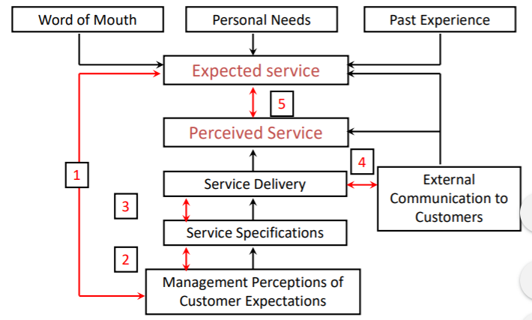

Customer expectations-management perception gap
- Gap 1 in the model shows how management may have inaccurate perceptions of what consumers actually expect and value in the offering.
- Reason for this gap is a lack of proper customer focus, and this gap can be reduced using focus groups and customer surveys to get feedback on what customers expect

Service quality specification gap
- Gap 2 in the model shows how management may have some inability to translate perceived customer expectations into service quality specifications.
- This gap relates to aspects of service design;

Service delivery gap
- Gap 3: how well are these specifications actually delivered? Guidelines for service delivery do not guarantee high-quality service delivery. There are several possible reasons for this:
  - Lack of sufficient support for frontline staff
  - Ineffective recruitment: employees should fit well with the firm’s culture and be well-trained.
  - Wrong incentives for employees; employees’ incentives should create goals for them which are aligned to the firm’s. Employee performance variability
  - Education gap for customers: don’t understand their role, unable or unwilling to perform their role
  - Process itself could be badly designed.

External communication gap
- Gap 4: communication gap when fashioning customer expectations using the external communications of an organisation, such as advertising
- A realistic expectation will normally promote a more positive perception of service quality. A service organisation should ensure its external communication accurately describe its service offering.
  - Virtuous cycle whereby effective communication attracts a target market segments whose preferences are aligned with the firm’s competitive priorities in their offering

Expected service – perceived service gap
- Gap 5: the sum of these 4 gaps is the difference between expected service and perceived service.

White Bread company example
- If the system is flawed the workers cant do anything to hit quality standards
- System is owned by the managers, therefore quality must start with management
- Numerical goals and standards, slogans and extrinsic motivation can all be useless if the system does not allow for flexibility
- A process can be stable (natural variation), in control , yet still be producing defective items 100% of the time. Defect rate within 3 standard deviations of the mean is defined as stable

Total Quality Management offering
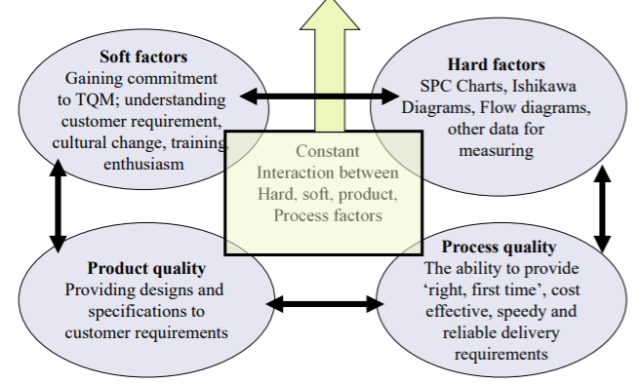
- TQM is a constant interaction between hard, soft, process quality and product quality factors

Soft factors
- Gaining commitment to TQM, understanding customer requirements, cultural changes, employee training, employee enthusiasm

Hard factors
- SPC charts, Ishikawa diagrams, flow diagrams and other data for measuring quality

Product quality
- Providing designs and specifications which delivery customer requirements

Process quality
- The ability to provide ‘right, first time’, cost effective, speedy and reliable delivery requirements

Conclusions
- All processes produce output that exhibits variation (Shewhart, Deming)
  - Where there is variation, there is potential for process improvement
  - Ineffective reward and punishment systems can tamper with a stable system. Superstitious knowledge affected decisions
- Quality is the alignment of customer requirements, specifications and performance
  - Customer requirements are influenced by a variety of factors and evolve over time
  - Quality of service is the difference between performance and expectations, so organisations should focus on customer perceptions
- If process can’t meet customer requirements (1) system is improved, (2) data is changed/lied about the defect number or (3) process is changed (picking out the red beads)
  - Hospitals admit patients into ghost wards just before 4 hour fine limit or close hospital to ambulances – fudging process to avoid defects, so the process needs to be improved

Textbook notes

How can quality problems be diagnosed?
- If the perceived quality gap is that customers’ perception of the product/service fail to match their expectations of it, the reasons must lie in other gaps in this model
  - Customer specification-operation’s specification gap. Mismatch between the organisation’s internal quality specification and the one expected by the customer.

Different domains of quality
- Most basic level is quality (offering-centric). This is focused on the basic characteristics of the product or service.
  - In a supermarket: quality of goods, cleanliness and staff courtesy
- Wider level is the quality of service (provider-centric). This is concerned with how the product or service is delivered and communicated.
  - In a supermarket: speed of service, predictability of service, range of goods stocked
- Broadest level is quality of experience (user-centric). This is how the product or service is used or consumed in the user’s individual context.
  - In a supermarket: do the opening hours suit customer X? Is what customer X wants available?

Sandcone theory
- Endorsement of quality as a driver of improvement. Stable foundation of quality allows a firm to develop dependability, speed, flexibility and cost.
- Improvement is a cumulative process, not a sequential one. Firms should first reach a minimally acceptable level of quality before tackling the next issue, internal dependability.
  - Each “next stage” requires maintenance and improvement in the previous stages, e.g. quality + dependability, quality + dependability + speed.

Conformance to specification

Define quality characteristics
- Quality can generally be summarised by a set of quality characteristics.
  - Functionality
  - Appearance
  - Reliability
  - Durability
  - Recovery
  - Contact

Decide how to measure each statistic
- Characteristics must be defined in a way which enables them to be measured thus controlled. This can involve breaking down general characteristics such as appearance as far as possible into its constituent elements, for example colour match, number of visible scratches, surface finish
  - These are more objective and ideally will be quantifiable
- Characteristics such as “courtesy” are more difficult to measure, but are important in operations with high customer contact. Here, firms try to measure customer perceptions of courtesy, but this poses risks of biases.
- Measures used to describe quality characteristics can be categorised into variables and attributes. Variables exist on a continuous scale, whereas attributes are binary and assessed by judgement (yes or no, right or wrong)

Set quality standards
- Once identify how quality characteristics are measured, set standards against which they can be checked. Otherwise we wont know good from bad performance.
- These standards may be constrained by operational factors such as technology and cost limits.
- However, they must also be appropriate to meet the expectations of customers. Thus the problem is constrained optimisation.
  - Can be hard to set the standard – should firm’s aim for a comparable complaint level to other firms, or simply minimise their own?

Control quality against those standards
- After setting appropriate standards, check that output conforms to those standards by doing things right first time, every time. This involves 3 decisions:
  - Where in the operation should conformance be checked?
  - Should it check every product or just take a sample?
  - How should the checks be performed?
- Checks can be performed on incoming resources to make sure they conform to the specification, i.e., universities screening applications to reduce variation and ensure students have high changes of success. Checks may also take place before particularly costly processes and immediately after processes with high defect rates, before potential damage to following processes and to avoid customers experiencing non-conformance.
- It may seem ideal to check every product/service, but samples are often more practical
  - Can be dangerous to inspect everything e.g., blood samples
  - Checking everything may destroy the product or interfere with the service e.g., light bulbs, waiters constantly checking if customer is enjoying a meal
  - Checking everything is time consuming and costly
- Most common approach for checking quality is sampling, then making inferences about all output from a process using statistical process control. SPC looks at the variability in the performance of the process to check whether the process is in control.
  - Reducing variability is one of the most important objectives of quality improvement

Find and correct causes of poor quality, and continuously improve
- Most important and most difficult. However, one aspect has made the improvement activity self-sustaining – total quality management
- Causes can be identify using the 5 whys

Total Quality Management
- A logical extension of the progression of quality-related practice from inspection and rejection to quality control to quality assurance
  - From inspection to control to assurance to TQM, there is an increasing strategic significance of quality management and an increasingly widespread use in the organisation
- TQM meets the needs and expectations of customers. Customer perspective is particularly important (customer-centricity). We start with an insight into customer needs, perceptions and preferences, then translate this into quality objectives and use it to drive quality improvements.
- TQM covers all parts of the organisation. Every agent is thought of as a supplier and customer internal to the firm. The implication is that errors in the goods and services provided internally in the organisation will eventually affect the external offering to the customer.
  - Some firms formalise this concept by requiring different departments to use service-level agreements with each other. These are formal definitions of the service dimension and the relationship between the parties.
    - Examples could include response times, range of services, dependability of supply, for both ‘standard’ and ‘special’ services (which would also be defined).
- TQM considers all costs of quality. Cost of controlling quality is not small and can be categorised into prevention costs, appraisal costs, and internal and external failure costs.
  - Prevention costs include identifying potential problems and putting the process right before poor quality occurs, training and development of personnel
  - Appraisal costs are associated with controlling quality to check if errors occurred during and after the creation of the product. These include setting up statistical sampling plans, the time and effort required to inspect inputs, processes, and outputs, obtaining data and conducting customer surveys
  - Internal failure costs include the cost of scrapped parts and materials, rework costs, lost production time and the lack of concentration as time is spent on troubleshooting rather than improvement
  - External failure costs include the loss of customer goodwill affecting future business, litigation, warranty costs and aggrieved customers who may take up time

Relationship between quality costs, quality cost model
- Traditionally quality management assumed failure costs fell at a decreasing rate as money spent on prevention and appraisal increased. Cost of quality provision increases at a constant rate, meaning there is an optimum amount of quality effort to be applied in any situation.
  - This minimises the overall cost of quality (failure + prevention costs)
- TQM argues we should not accept the inevitability of errors, and argues failure costs in the traditional model are greatly underestimated, as management time wasted by failures is rarely accounted for. TQM also argues prevention costs, whilst inevitably high, are simply transferred from a designated inspector to each worker.
  - For these reasons, TQM believes the optimum amount of quality effort is much further to the right, i.e. more effort.

Further reading

Understanding Variation (Provost and Nolan)
Misunderstanding common and special causes of variation risks economic and psychological losses.
- Managers’ decisions are based on interpreting patterns of variation in the figures available to them, both internally (e.g. sales figures) and externally (interest rates etc)
  - Managers must understand whether the variation is a trend, or just random variation similar to what has been observed in the past. Losses from misinterpretation include:
    - Blaming people for problems beyond their control
    - Spending money for new equipment that isn’t needed
    - Wasting time looking for explanations of a perceived trend when nothing has changed

Common and special causes of variation
Definitions:
- Process: causes and conditions that repeatedly come together to turn inputs into outputs. System: group of processes and people with common purpose.
- Shewhart finds variation in a quality characteristic has two types of causes. Common causes (inherent to the process) and special causes (not inherent to the process, arise because of specific, asymmetric circumstances)
  - Common cause occur hour after hour and affect everyone in the process
  - Special cause are not always part of the process and may not affect everyone in the system.
- Identified using the Shewhart control chart, which operationally defines the concept of a stable process. Contains a centreline, the average value, and control limits which are the variation expected due to common causes.
  - A process or system which has only common cause variation is called a stable process, or in a state of statistical control
  - A process where outcomes are affected by both common causes and special causes is an unstable process – magnitude is not necessarily large, but it is unpredictable.
  - So as special causes are identified and removed, the process becomes stable. Causes of variation remain constant, Deming gives several benefits to this:
    - Predictable, therefore makes planning easier
    - Cost and quality are predictable
    - Productivity maximised and costs minimised.
    - Effect of changes to the process can be measured with greater speed and reliability as there is less noise.

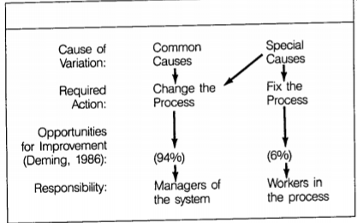
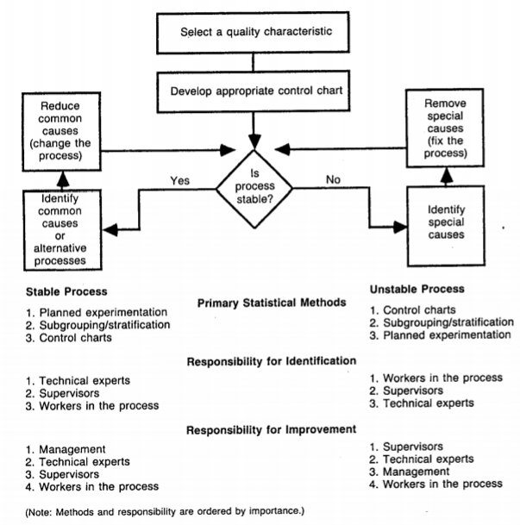

Gawande (2007), The New Yorker. How checklists can improve quality
- Intensive care units have expanded the range of injuries human bodies can survive by taking artificial control of human bodies. Israeli scientists found that the average patient required 178 individual actions per day, and every one of them posed risks.
  - Observed error rate of just 1%, but this is still two errors per day per patient.
  - Half of I.C.U. patients experience a serious complication, which decreases survival chances
- The solution the medical profession has adopted to handling the complexity of performing all these daily tasks, in a disruptive environment, is specialisation.
  - 50% of ICUs now employ an intensivist, and intensive care specialist.
  - Putting an intensivist on staff reduced death rates by a third (Provonost, 1999)
  - Key advantages are a greater knowledge of the details that matter and an ability to handle the complexity of the job.
  - However, ICU medicine has become so complex that avoiding daily mistakes is impossible even for super specialists. What do you do when expertise is not enough?
- Model 229 Boeing aeroplane was bidding to be the next generation of US bombers, but crashed during the “competition” as the pilot was unable to handle the new level of complexity and the number of tasks this model required.
  - Pilots got together to consider what to do. They couldn’t find anyone with more expertise than the pilot who crashed.
  - Simple solution of creating a pilot’s checklists with step-by-step checks. The existence of this indicating how far aeronautics had advanced, as this was previously unnecessary.
  - With this checklist in hand, the B-17 was flown 1.8 million miles without one accident, and 13,000 were ordered by the Army.
- Its not clear whether something as simple as a checklist could improve quality in medical care as sick people are a lot more various than aeroplanes.
  - 41,000 trauma patients had 1,224 different injury-related diagnoses in 32,261 unique combinations. This makes mapping out proper steps for each one impossible.
- Peter Pronovost decided to make a checklist covering line infections. He plotted the steps to take to avoid infections, with nurses observing that in more than a third of patients at least one step was skipped. Provonost then empowered nurses to stop doctors if they skipped a step on this checklist.
  - Formally authorising nurses (as opposed to nudging doctors) made the situation clear and ensured all of the steps would be followed every time.
  - Line-infection rate fell from 11% to 0, saving $2m
  - Programme was extrapolated to create more checklists for various procedures. This improved the consistency of care, with the average ICU stay dropping by 50%
- Checklists help with memory recall, especially for mundane matters easily overlooked during drastic events, and made explicit the minimum expected steps in a complex process. However few hospitals initially adopted the idea, for various reasons.
  - Some physicians offended by the idea they needed checklists.
  - Doubts over evidence due the small sample size of only one hospital.
    - Checklists implemented in Michigan’s ICU decreased infection rates by 66%, saving an estimated $175m.
- Some resistance due to culture; medical profession is somewhat of a Rockstar profession, requiring courage, improvisation and charisma. Checklists and standard procedures feel like the opposite, which creates some resistance.

Deming – “A Prophet Unheard” video
- Majority of problems come from processes, equipment and designs – not people
- Statistician by training
- Eliminate waste was a key message during the war effort
- Shewhart (1931) what can be measured must be measured exactly; control charts show what is in statistical control and what is not
- Fishtail diagram; any system is the sum of its human parts. System must have an aim, and everyone must know about it.
- Deming circle / quality control circle
- Key principle starts with respect for the human being. Poor quality of American cars was to blame when losing market share to Honda.
- Key was reduced variation in Japanese gears which improved the transmission in Japanese cars. Quality transformation prompted by Deming was behind Ford’s success in 1980
- TQM then developed.
- Deming was against performance related pay

MasterControl (Manalan, 2018)
Quality Problems: Beyond Root Causes to ‘Real Causes’: https://www.mastercontrol.com/gxp-lifeline/quality-problems-beyond-root-causes-to-real-causes/
- Discovery of the change causes a quality problem, then reversing this change and preventing it from happening again, is basic root cause analysis and corrective action plan. However each root cause seems unique, so we may never see a pattern or bigger picture
Allan Sayle (1988) proposes 6 ‘real causes’ of quality problems:
- Lack of organisation – undetermined responsibilities and authorities, undefined management systems, inadequate communications
- Lack of training – inadequate schooling and company training
- Lack of discipline – examples set by managers, companywide quality culture, personal attributes, demotivating environments
- Lack of resources – overly-complex management systems, unrealistic estimates, inadequate reinvestment and failure to modernise, uneven allocation
- Lack of time – overcomplications, unrealistic commitments, irresponsible attitudes, excessive workloads, selfishness
- Lack of top management support – attitude and motivation, time management, ‘cancer of complacency’

8 dimensions of quality (Garvin, 1987)
- US consumers desiring increased quality – before Japanese and EU competition, most quality programmes were not implemented with serious intent.
8 critical dimensions of quality serve as a framework for strategic quality analysis:
- Performance of primary operating characteristics – typically measurably attributes on which brands can be rank objectively. However overall performance ranking is complicated where they create benefits not every customer needs.
  - Superior performance can depend on the task
  - Performance can also be based on the customer e.g. people with normal v sensitive skin – whether performance differences are quality differences may depend on circumstantial preferences, but based on functional requirements, not taste
  - Some performance standards are based on subjective preferences which are so universal they have the force of an objective standard.
- Features are the secondary aspects of performance, the bells and whistles that supplement basic functioning. Line between primary and secondary is difficult to draw, but again features involve objective and measurable attributes; individual needs, not prejudices, affect their translation into quality differences.
  - Sometimes choice between features is quality – the flexible approach
- Reliability – probability of a product malfunctioning within a specified time period (mean time to first failure).
  - Most important to customers where downtime or maintenance is expensive
- Conformance – degree to which design and operating characteristics meet established standards / specifications. Specification is the centre, deviance from this permitted only within a specified range.
  - Can lead to tolerance stack up; one part at lower spec limit being fitted to another part at upper spec limit. More likely to fail.
    - Taguchi’s loss function is the solution – better to cluster to the centre, even if some parts fall outside the tolerance band.
- Durability has economic and technical dimensions. Technically, amount of use before deterioration. Economically, how much use before investment and operating costs for a new model are less than the operating costs of the current model.
  - Durability closely linked to reliability – product that fails earlier and more often will have higher repair costs, hence more likely to be replaced by a newer model.
  - Durability figures should be interpreted with care – increased product life may not be due to technical improvements, but changing underlying economic incentives
- Serviceability – speed, courtesy, competence and ease of repair.

